EXNO: 1
Estimation of Characteristic Impedance (Zo), and Propagation Constant (γ) of a Transmission Line from Primary Constants
Test Case 1:
Investigating the significance of Characteristic Impedance (Zo), and Propagation Constant
(γ) of a Transmission Line using the following parameters
Program :
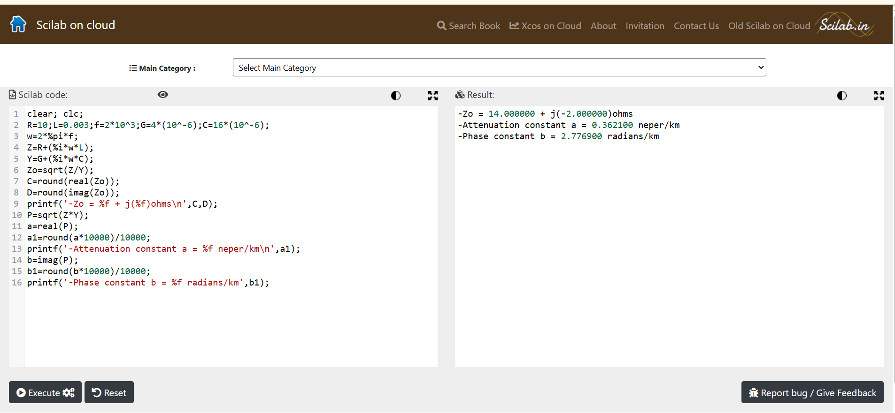


Output:

Test Case 2:
Examine the impact of resistance and inductance on the significance of Characteristic
Impedance (Zo) and Propagation Constant (γ) of a Transmission Line at a frequency f=2.5
Khz. Vary the resistance value from 10 Ω to 50 Ω at the interval of 10 Ω with L,G and C
values constant and calculate the Characteristic Impedance and Propagation Constant .
Vary the inductance values from 3.5 mH to 11.5 mH at the interval of 2.5 mH with R,G and
C values constant.
PROGRAM
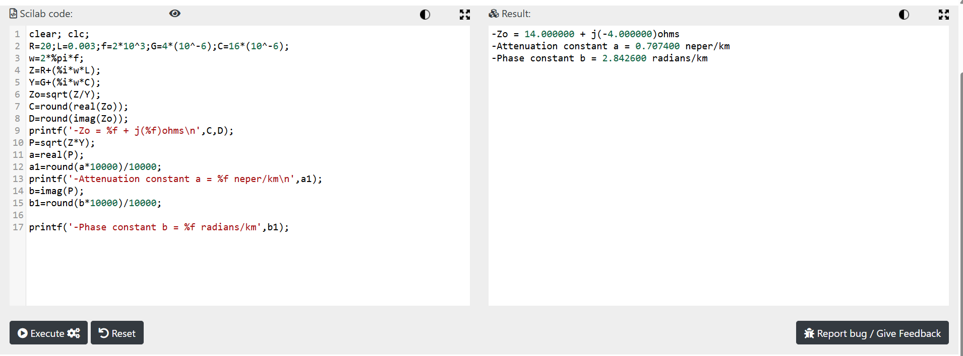

OUTPUT:


Test Case 3:
Explore the impact of frequency and capacitance on the significance of Characteristic
Impedance (Zo) and Propagation Constant (γ) of a Transmission Line. Vary the frequency
from 2KHz to 10 KHz at the interval of 2 KHz with L,R ,G and C values constant and
calculate the Characteristic Impedance and Propagation Constant . Vary the capacitance
values from 8 μF to 16 μF at the interval of 2 μF with R,G and L values constant.
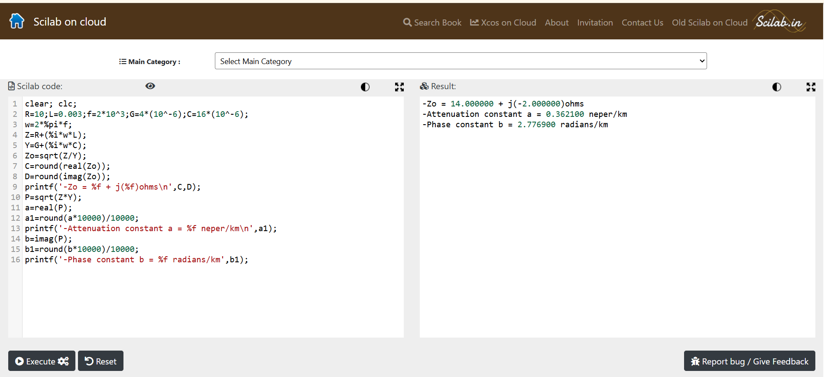
PROGRAM:


OUTPUT :

